What is verbal communication?
Verbal communication involves any type of communication that includes words, spoken, written or signed. The conversation you might have with a student, colleague or other stakeholder in the hallway, the morning talk shows or the websites we read in the morning; even a text message to a friend is a form of verbal communication. Our ability to communicate with language is based on the organisation of a system of words as opposed to merely sounds; is what has allowed our civilisation to develop to the modern age. Now, not only do we have language, but we also have technology, which allows us to send communications across incredible distances, even out of our solar system!
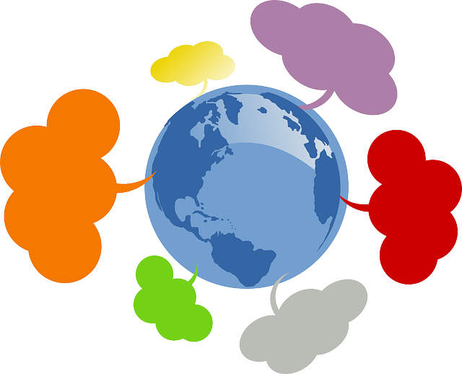

Why is Verbal Communication Important?
We use verbal communication to inform others of our needs and desires, or to impart knowledge to others. It has allowed us to develop our collective knowledge to point where we improve the lives of our offspring like no species before us.

Furthermore, verbal communication allows people to persuade, to apologise or provide deeper meaning and build relationships.

What is Non-Verbal Communication?
As verbal communication is the way we communicate using words, non-verbal communication involves any communication efforts we make that don’t use words to directly influence people. Instead non-verbal communication affects people’s perceptions and opinions in a subtle but still significant way. Non-verbal communication includes body language, gestures, facial expressions, eye contact and posture.

Touch is a non-verbal communication that not only demonstrates a person’s feelings or level of comfort but illustrates personality characteristics as well. A firm handshake or friendly hug indicates something very different to a pat on the head or a bashful handshake does.

Why is Non-Verbal Communication Important?
Non-verbal communication is vital to express emotions, communicate interpersonal relationships, support verbal interaction or to reflect personality. With it, we can reinforce, contradict, substitute, complement or emphasise our verbal communication all with the simple use of non-verbal communiqués.

The Purpose of Feedback
The purpose of feedback is to provide information and observations about a student, colleague or other stakeholder. Lecturers should consider feedback to students, their colleagues and other stakeholders; to help them improve in the future. Feedback differs from advice; quality feedback is primarily intended to be a simple list of negative and positive observations about their work. Ultimately the person receiving the feedback decides how to use the information given, so care must be given to provide specific suggestions on how to improve. It should also include questions or other interactions with the receiver to ensure that the feedback was properly understood.

Different ways of getting feedback
- Surveys
- Surveys are the bread and butter for getting feedback. They’re easy to set up, easy to send out, easy to analyze, and scale very well. What’s not to like?
- Feedback boxes
- Do you have a structured process for receiving feedback from your customers? Well, you should.
- Reach out directly
- This is one of my favorites. It’s also one of the most undervalued. If you want to truly understand somebody, you really need to go talk to them.
- User activity
- Wouldn’t it be nice to know which features and which sections of your site people are actually using? And how often? Sure, we can use web analytics products to get a sense of what the total usage is like. But what does an individual use?

